SIMATS ENGINEERING
ASSESSMENT TOOL 2

COURSE NAME: COMPUTER NETWORKS
COURSE CODE: CSA0713

COURSE OUTCOME COVERED

CO2: Configure IP addressing schemes, subnetting, and basic routing techniques using simulation tool, for efficient network design and topology. (BL3)

Assessment Tool Weightage: 30%

Annexure A

Scenario-Based

Code of Conduct:

I KAVINILAVU.S(192565038)_ (Name / Reg No) certify that this submission is my original work and that I have adhered to the guidelines specified for this assessment.
I understand that any violation of academic integrity rules will result in disciplinary action.

Signature of the student:
KAVINILAVU.S

Annexure A

Scenario-Based

1. A newly established Smart Campus is deploying a secure network infrastructure for its academic and administrative departments. The network administrator has been allocated the IP address block 192.168.100.0/24. Based on the expected number of devices, the following subnet masks have already been assigned:
School of Computing → /25
School of Electronics → /26
School of Mechanical Engineering → /27

As the network engineer, design the subnet allocation by performing the following tasks:
- Determine the network address and broadcast address for each department.
- Identify the valid host IP address range for each subnet.
- Calculate the number of usable host addresses available in each subnet.
- Determine the remaining unused IP address range within the given network block.

1. Understanding of the Scenario
The Smart Campus has been allocated a single Class C private block, 192.168.100.0/24 (256 total addresses). Three departments — School of Computing, School of Electronics, and School of Mechanical Engineering — must be carved out of this block using the fixed subnet masks /25, /26, and /27 respectively. Because the masks are unequal, this is a Variable Length Subnet Masking (VLSM) problem: the largest subnet must be allocated first so that each following block starts on a correct address boundary.

2. Key Issues Identified
- Three departments need to fit inside one /24 block without address overlap.
- Subnet sizes are unequal (/25, /26, /27), so allocation order and boundary alignment matter.
- Each subnet needs its network ID, broadcast ID, usable host range, and host count identified.
- Any address space left after allocation must be tracked for future departments.

3. Application of Concepts — Subnet Calculations
Allocating in descending order of size (largest block first) keeps every subnet aligned on a valid boundary:
Department | Subnet (CIDR) | Network Address | Broadcast Address | Valid Host Range | Usable Hosts
School of Computing | 192.168.100.0/25 | 192.168.100.0 | 192.168.100.127 | 192.168.100.1 – .126 | 126
School of Electronics | 192.168.100.128/26 | 192.168.100.128 | 192.168.100.191 | 192.168.100.129 – .190 | 62
School of Mech. Engg. | 192.168.100.192/27 | 192.168.100.192 | 192.168.100.223 | 192.168.100.193 – .222 | 30

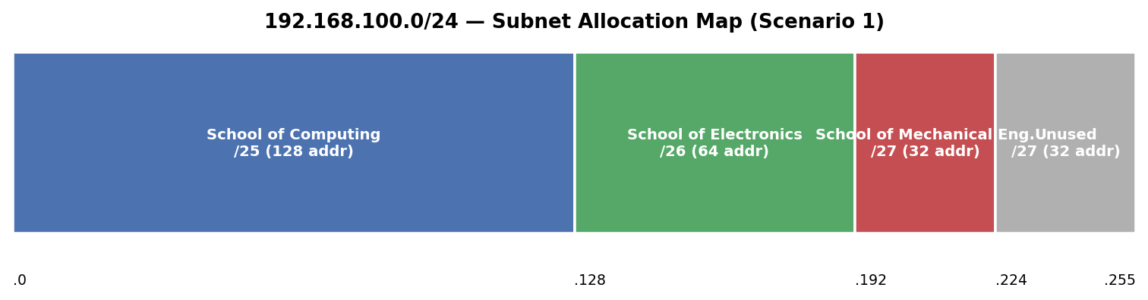
Figure 1: Address-block map of 192.168.100.0/24 across the three departments.

4. Decision Making — Remaining Address Space
Used addresses: 128 + 64 + 32 = 224 out of 256
Remaining unused block: 192.168.100.224 – 192.168.100.255 (a /27-sized block of 32 addresses)
Recommendation: reserve this /27 for future departments (e.g., a Library or Admin block) or for point-to-point router/uplink addressing, rather than merging it back into an existing subnet.

2. A multinational software company is expanding its headquarters and has been assigned the private IP block 10.10.0.0/16. Different departments require different subnet sizes based on the number of employees. The network administrator has allocated the following subnet masks:
Software Development → /24
Quality Assurance → /25
Human Resources → /26
Executive Management → /27
As the network administrator, perform the following tasks:
- Determine the network address and broadcast address for each department.
- Identify the valid range of host IP addresses.
- Calculate the number of usable hosts in each subnet.
- Identify the unused IP address range remaining within the allocated IP block.
SOLUTION:
1. Understanding of the Scenario
The company holds the private block 10.10.0.0/16 (65,536 addresses) and must carve out four departments — Software Development (/24), Quality Assurance (/25), Human Resources (/26), and Executive Management (/27) — again a VLSM allocation, this time inside a much larger address space with significant room left for future growth.
2. Key Issues Identified
- Four departments of very different sizes must share one /16 without overlap.
- Largest-to-smallest allocation order is required to keep subnet boundaries valid.
- The organisation will want a clear picture of how much of the /16 remains free for future departments or data-centre growth.

3. Application of Concepts — Subnet Calculations
Department | Subnet (CIDR) | Network Address | Broadcast Address | Valid Host Range | Usable Hosts
Software Development | 10.10.0.0/24 | 10.10.0.0 | 10.10.0.255 | 10.10.0.1 – .254 | 254
Quality Assurance | 10.10.1.0/25 | 10.10.1.0 | 10.10.1.127 | 10.10.1.1 – .126 | 126
Human Resources | 10.10.1.128/26 | 10.10.1.128 | 10.10.1.191 | 10.10.1.129 – .190 | 62
Executive Management | 10.10.1.192/27 | 10.10.1.192 | 10.10.1.223 | 10.10.1.193 – .222 | 30
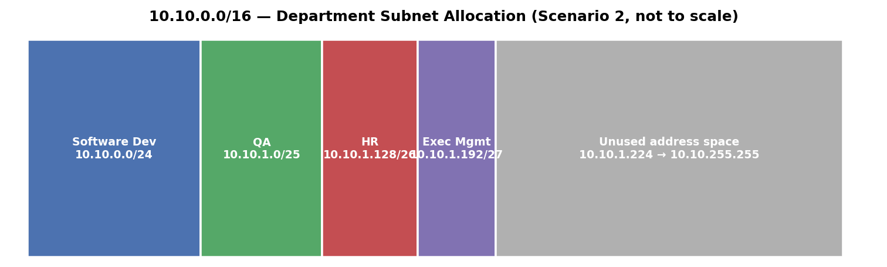
Figure 2: Departmental allocation inside 10.10.0.0/16 (illustrative, not to scale).

4. Decision Making — Remaining Address Space
Used addresses: 256 + 128 + 64 + 32 = 480 out of 65,536
Remaining unused block: 10.10.1.224 – 10.10.255.255 (65,056 addresses fre

3. A smart hospital is migrating its network infrastructure from IPv4 to IPv6 to support thousands of connected medical devices and IoT sensors. The hospital has been assigned the IPv6 network:
2001:0db8:abcd:0000:0000:0000:0000:0000/64
As the network engineer responsible for the migration, perform the following:
- Convert the given IPv6 address into its compressed notation.
- Expand the compressed address back into its full hexadecimal representation.
- Identify the network prefix using the /64 prefix length.
- Calculate the total number of host addresses supported within the subnet.
- The Total number of possible host addresses available within this network.

SOLUTION:

1. Understanding of the Scenario
The hospital is moving from IPv4 to IPv6 to support a very large number of medical devices and IoT sensors — a use case IPv4 cannot scale to. It has been assigned the network 2001:0db8:abcd:0000:0000:0000:0000:0000/64, and the task is to express this address correctly in both compressed and expanded form, identify the network prefix, and quantify how many devices it can support.

2. Key Issues Identified
- IPv6 addresses are 128 bits, written as eight 16-bit hextets — verbose in full form.
- Compression rules (:: for consecutive all-zero blocks, leading zero removal) must be applied correctly and only once per address.
- A /64 prefix is the standard boundary between the routing (network) portion and the interface ID (host) portion.

3. Application of Concepts
Compressed notation: 2001:db8:abcd::/64
Expanded (full) notation: 2001:0db8:abcd:0000:0000:0000:0000:0000
Network prefix (first 64 bits): 2001:0db8:abcd:0000 → written as 2001:db8:abcd::/64
Host (Interface ID) portion: remaining 64 bits — 0000:0000:0000:0000, freely assignable to devices
Total possible host addresses: 2^(128 − 64) = 2^64 = 18,446,744,073,709,551,616 addresses
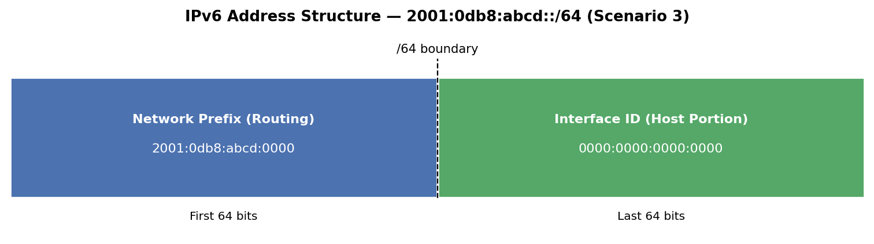
Figure 3: 128-bit IPv6 address split at the /64 boundary into network prefix and interface ID.

4. Decision Making
A single /64 gives the hospital roughly 18.4 quintillion addresses — vastly more than any realistic count of medical devices and IoT sensors, so no further subnetting of the host portion is needed for addressing capacity. In practice the hospital can still subdivide the /64 (e.g., per ward or per device class) using SLAAC-friendly /64 subnets from a larger prefix such as a /48 or /56 issued by its upstream provider, keeping each functional area on its own /64 for isolation and easier access control.

4. An Internet Service Provider (ISP) connects multiple customer networks through a core router. The router maintains the following routing table entries:
192.168.1.0/24
192.168.2.0/24
192.168.3.0/24
A packet arrives at the router with the destination IP address:
192.168.2.45
As the routing engineer, determine:
- The destination subnet to which the packet belongs.
- The matching routing table entry.
- The next-hop network/interface used to forward the packet.
- The default route that should be used if the destination does not match any routing table entry.
SOLUTION:
1. Understanding of the Scenario
An ISP core router holds three directly connected subnets — 192.168.1.0/24, 192.168.2.0/24 and 192.168.3.0/24 — in its routing table. A packet destined for 192.168.2.45 arrives, and the router must decide which entry to match and where to forward it, plus what happens if no entry matches at all.
2. Key Issues Identified
- The router must test the destination address against each routing table entry to find the correct subnet.
- Only one of the three /24 entries can contain 192.168.2.45.
- A fallback (default route) is needed for any destination that matches none of the specific entries.

3. Application of Concepts
Question | Answer
Destination subnet | 192.168.2.0/24 (192.168.2.45 falls between .0 and .255 of this subnet)
Matching routing table entry | 192.168.2.0/24
Next-hop / interface used | The router interface / next-hop configured for the 192.168.2.0/24 entry (i.e., the LAN interface directly attached to that subnet)
Default route (no match case) | 0.0.0.0/0 — forwards any otherwise-unmatched packet to the ISP's upstream/default gateway
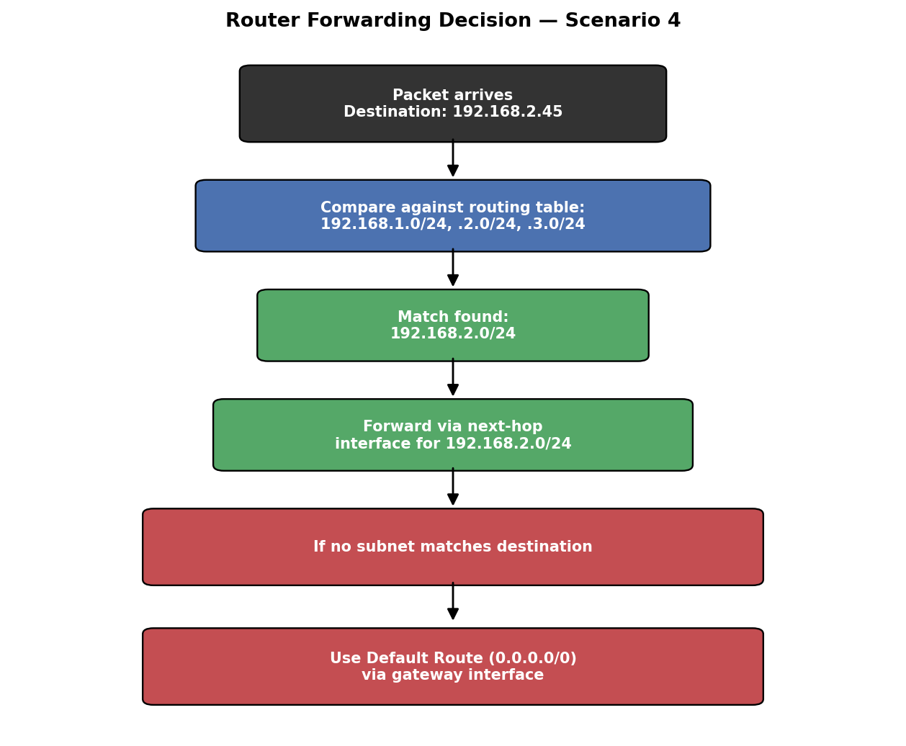
Figure 4: Router's longest-match forwarding decision for 192.168.2.45.
4. Decision Making
Because 192.168.2.45 lies strictly within 192.168.2.0 – 192.168.2.255, the router forwards the packet out the interface bound to 192.168.2.0/24. If the destination had instead been, for example, 192.168.4.10 — which matches none of the three entries — the router would fall back to its default route (0.0.0.0/0) rather than dropping the packet, provided a default route is configured.

5. A company establishes two office departments connected through a Layer-3 router. The allocated subnet information is as follows:
Administration LAN → 192.168.10.0/26
Finance LAN → 192.168.10.64/26
The router interfaces are configured with:
Administration Gateway → 192.168.10.1
Finance Gateway → 192.168.10.65
As the network administrator, perform the following tasks:
- Determine the network address and broadcast address for each LAN.
- Identify the valid host IP address range.
- Suggest suitable IP addresses for three computers in each LAN.
- Identify the default gateway that hosts in each LAN should use for communication.
SOLUTION:
1. Understanding of the Scenario
A company runs two LANs — Administration (192.168.10.0/26) and Finance (192.168.10.64/26) — connected through a Layer-3 router acting as the gateway for each. The task is to confirm each subnet's boundaries, propose valid host addresses, and confirm the correct default gateway for each LAN.
2. Key Issues Identified
- Both LANs use /26 masks (64 addresses each) carved from the same 192.168.10.0/24 space.
- Each LAN's router interface address (.1 and .65) must fall inside that LAN's valid host range.
- Hosts in each LAN must be configured with the matching gateway to reach the other LAN or the internet.

3. Application of Concepts — Subnet Calculations
LAN | Subnet (CIDR) | Network Address | Broadcast Address | Valid Host Range
Administration | 192.168.10.0/26 | 192.168.10.0 | 192.168.10.63 | 192.168.10.1 – .62
Finance | 192.168.10.64/26 | 192.168.10.64 | 192.168.10.127 | 192.168.10.65 – .126
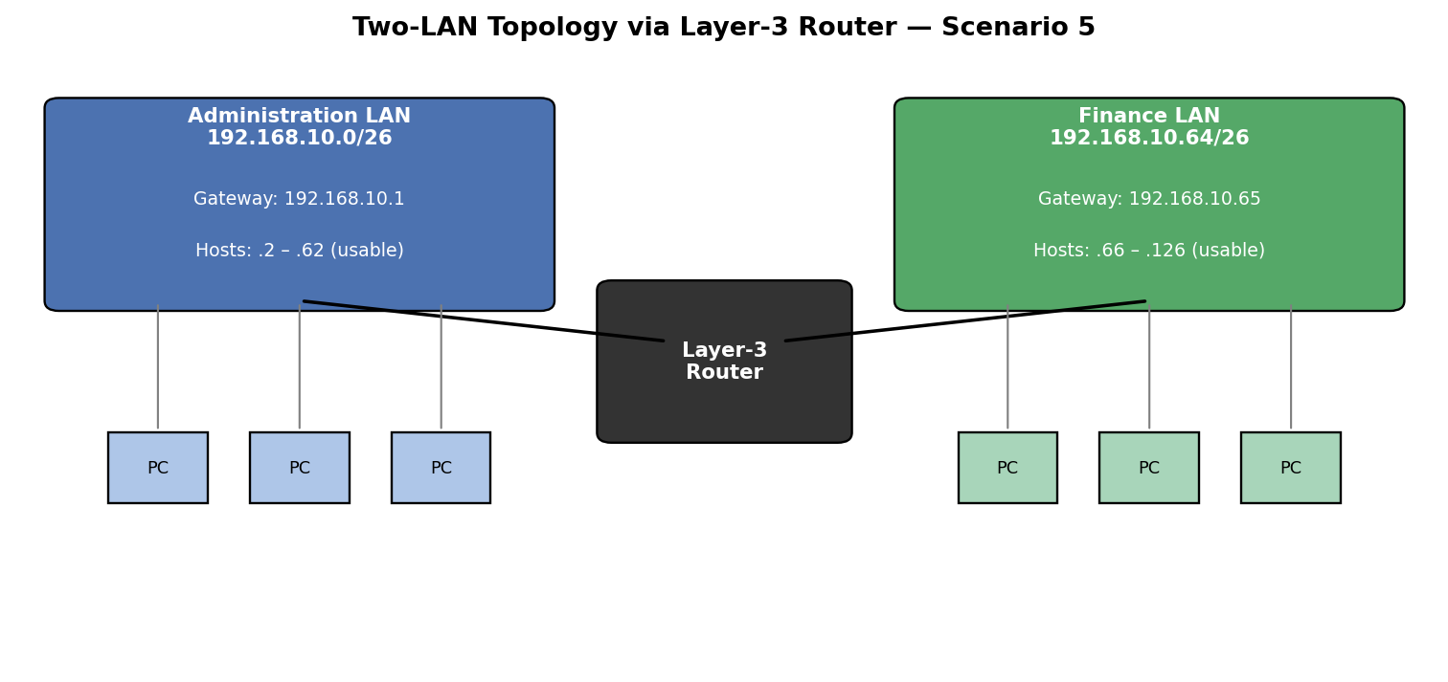
Figure 5: Administration and Finance LANs connected through the Layer-3 router.

4. Decision Making — Suggested Host IPs & Gateways
LAN | Suggested Host IPs | Default Gateway
Administration | 192.168.10.2, 192.168.10.3, 192.168.10.4 | 192.168.10.1
Finance | 192.168.10.66, 192.168.10.67, 192.168.10.68 | 192.168.10.65
Both suggested address sets avoid the network address, the broadcast address, and the gateway address itself (.1 and .65), which are reserved. Each LAN's hosts must point their default gateway to their own router interface — Administration hosts to 192.168.10.1, Finance hosts to 192.168.10.65 — so that inter-LAN and internet-bound traffic is correctly routed.

RUBRICS FOR CALCULATION

Scenario Based Assessment
Criteria | Weightage (%) | Level 4 (Exemplary) | Level 3 (Proficient) | Level 2 (Developing) | Level 1 (Beginning)
Understanding of Scenario | 20% | Demonstrates clear and complete understanding of the scenario and context | Shows good understanding with minor gaps | Partial understanding; misses key aspects | Misinterprets or fails to understand the scenario
Identification of Key Issues | 20% | Accurately identifies all relevant issues and factors involved | Identifies most key issues with minor omissions | Identifies limited issues; some irrelevant points | Unable to identify key issues
Application of Concepts | 25% | Applies appropriate concepts effectively to address the scenario | Applies concepts with minor errors | Limited or partially correct application | Unable to apply relevant concepts
Decision Making | 20% | Makes well-reasoned, logical decisions with strong rationale | Makes reasonable decisions with some justification | Makes weak decisions with limited justification | No clear decisions made or rationale provided
Clarity of Response | 15% | Response is clear, structured, and logically presented | Generally clear with minor issues | Somewhat unclear or poorly structured | Disorganized and difficult to understand

